

Name: Muhammad Faisal
Roll no: 2022F-BCS-152

Section: A
Instructor Name: Miss Fozia Khan
Course: Artificial Intelligence Lab (CS - 325L)
Program: (BS) - Computer Science

Lab #00

Tasks 01 : Install the anaconda Nav.
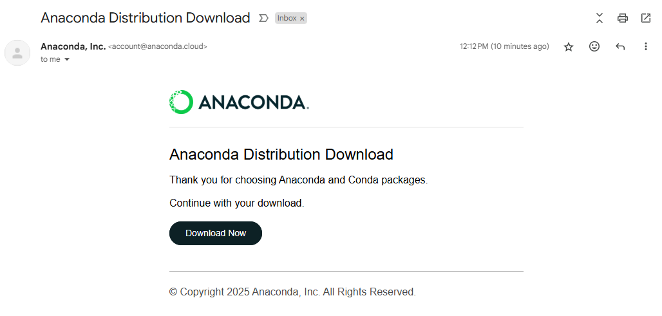

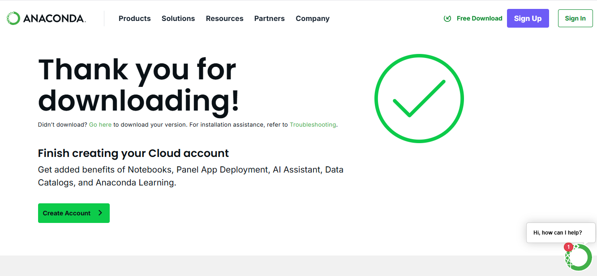

Task 02 : Answer the following.
- What is Environment?
In computing, an environment refers to a setup or space where software or applications run. It includes the configuration, tools, libraries, and system settings needed for development, testing, or deployment.
Examples:
- Development environment (for coding and testing)
- Production environment (for running the actual app used by users)
- Virtual environments (isolated setups for specific projects)
- Why do we make an Environment?
We make environments to:
- Keep things organized (separate development from production)
- Avoid conflicts between software packages or dependencies
- Test safely without affecting live applications
- Control versions of tools or libraries per project

- How do we make an Environment? Create one.
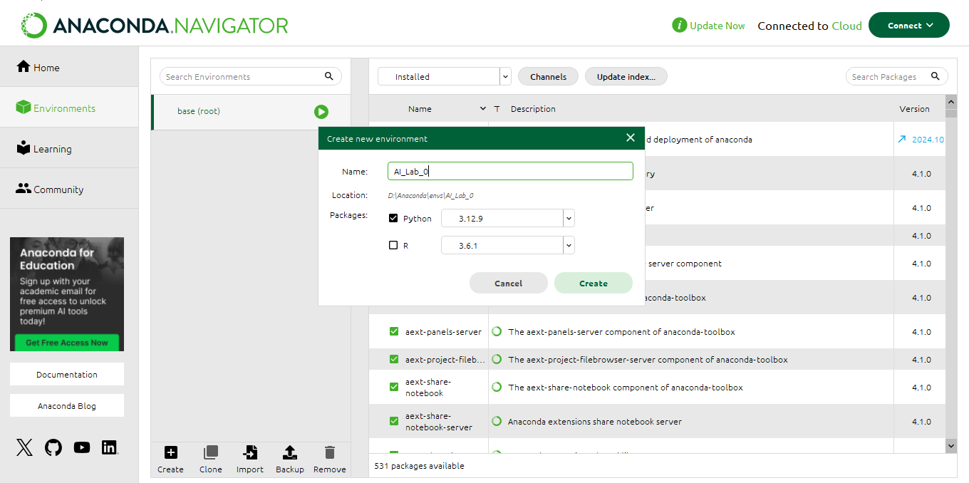

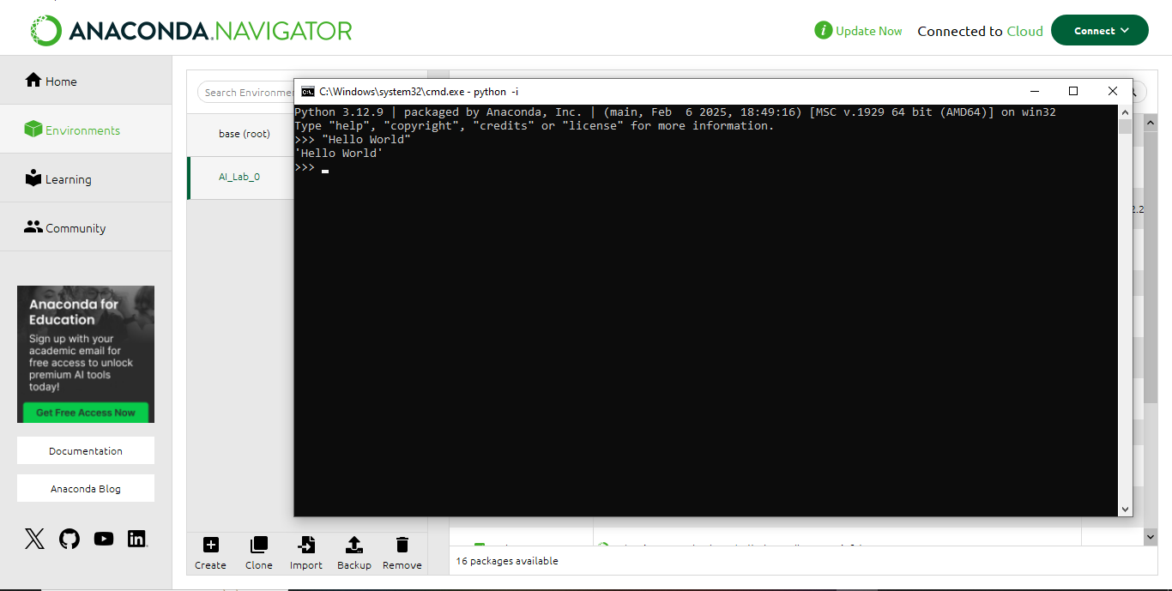

Task 03: Create an empty file on Jupyter notebook and rename it using your Roll no. [Show all the steps].
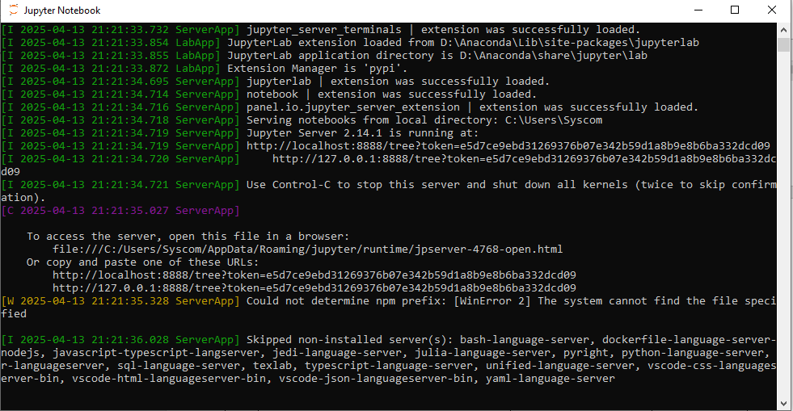

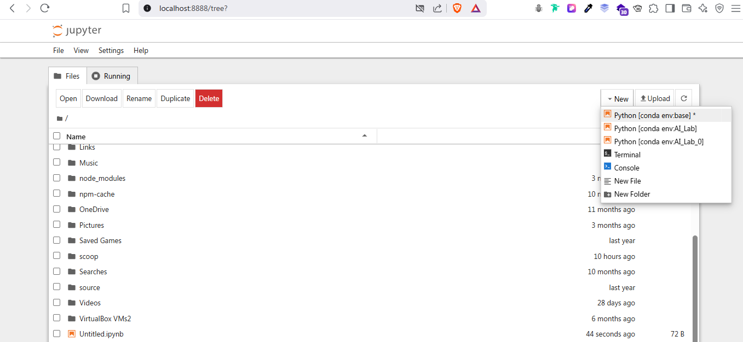

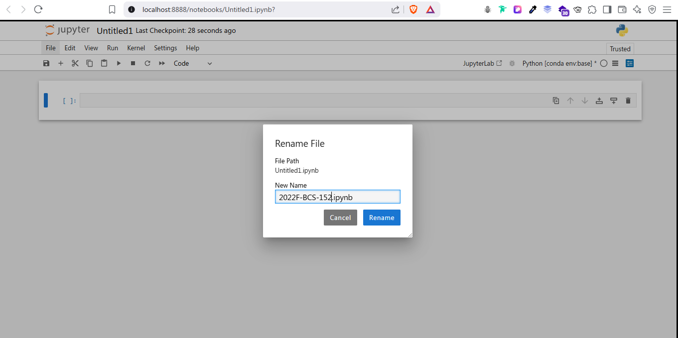

Task 04: Print your name along with your fathers on the notebook created earlier.
